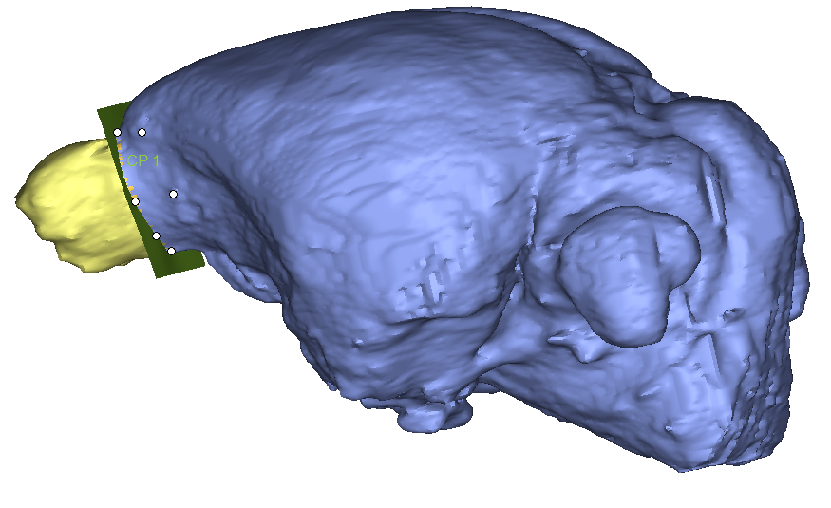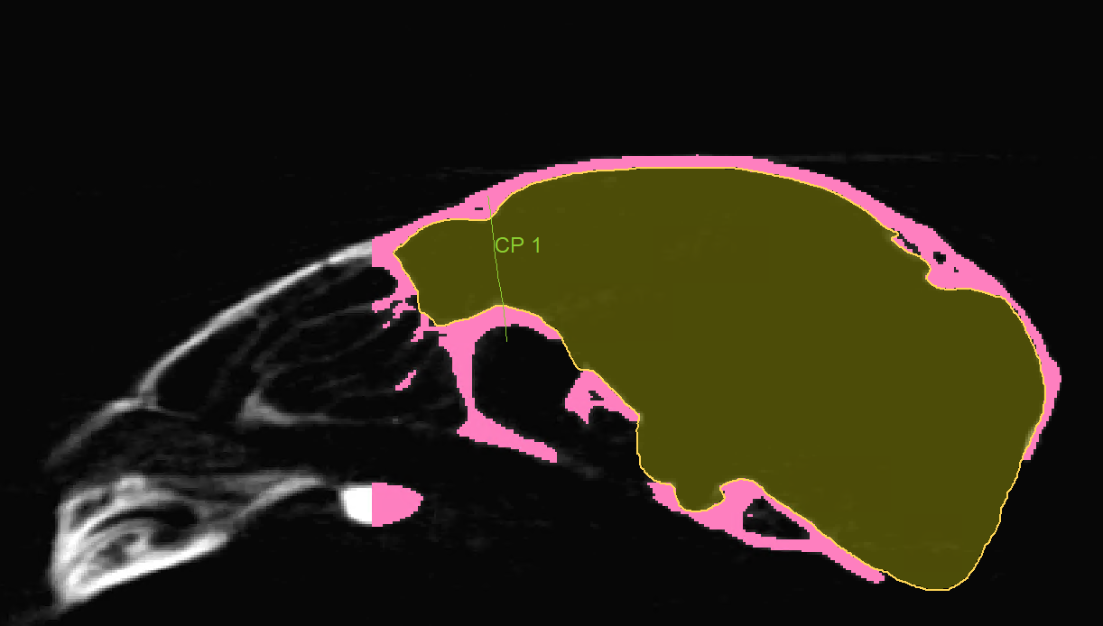

**Supplementary figures 1 and 2:** Images showing the area behind the cerebellum where the brain stem was cut, and an example of how the olfactory bulbs are cut off the remainder of the endocast. Specimen used for the example: Brachylagus_idahoensis_33612